Synopsis

Sentiment Analysis of Product Reviews using Machine Learning

Problem Id: 16

Student names :- University Roll no. :-
Devansh Panwar (Leader) 2028702
Rishabh Budakoti 2028820
Tushar 2028886

- Problem Description:
In today’s digital world, a large number of product reviews are generated on e-commerce platforms. Analyzing these reviews manually is time-consuming and inefficient. This project focuses on designing an end-to-end machine learning system that automatically classifies product reviews into positive, negative, or neutral sentiments.

The system uses Natural Language Processing (NLP) techniques to preprocess raw text data by removing noise such as punctuation, HTML tags, and stopwords. The cleaned text is converted into numerical features using TF-IDF vectorization. Multiple machine learning models including Logistic Regression, K-Nearest Neighbors (KNN), and Support Vector Machine (SVM) are trained to classify sentiments.

The performance of models is evaluated using accuracy, precision, recall, F1-score, confusion matrix, and ROC curve. This system helps businesses understand customer opinions, improve products, and make data-driven decisions efficiently.

- Steps of Implementation:
1. Data Collection:
Downloaded sentiment dataset from online sources.

2. Data Preprocessing:
Removed noise (punctuation, URLs, symbols)
Converted text to lowercase
Tokenization
Stopword removal
Lemmatization

3. Feature Extraction:
Used TF-IDF to convert text into numerical form

4. Data Splitting:
Split dataset into training (80%) and testing (20%)

5. Model Training:
Logistic Regression
K-Nearest Neighbors (KNN)
Support Vector Machine (SVM)

6. Model Evaluation:
Accuracy, Precision, Recall, F1-score
Confusion Matrix
ROC Curve
7. Prediction System:
User inputs review → system predicts sentiment
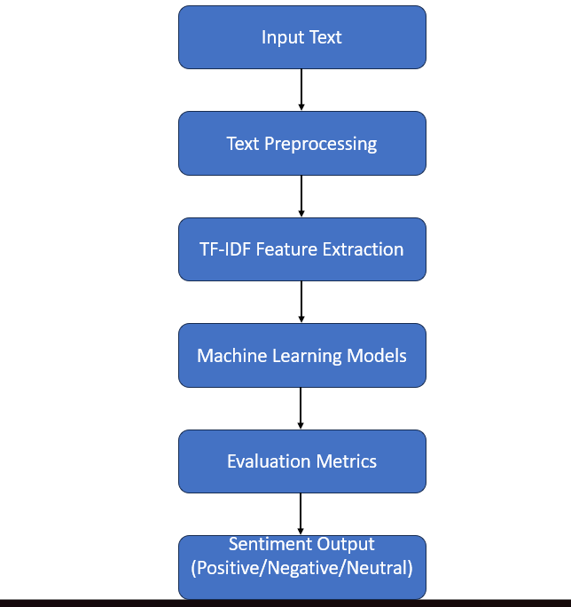

- Expected Modules/ Libraries to be used :
1. Pandas:
Used for reading and handling dataset.
2. NumPy:
Used for numerical computations.
3. NLTK:
Used for text preprocessing such as stopword removal and lemmatization.
4. Scikit-learn:
Used for ML models (Logistic Regression, KNN, SVM) and evaluation metrics.
5. Matplotlib:
Used for plotting graphs like ROC curve and accuracy comparison.
6. Re (Regular Expressions):
Used for cleaning text data.

- Expected Evaluation metrics and Plots to be used:
1. Accuracy:
Measures overall correctness of the model.
2. Precision:
Measures how many predicted positives are correct.
3. Recall:
Measures how many actual positives are detected.
4. F1-score:
Harmonic mean of precision and recall.
5. Confusion Matrix:
Shows correct and incorrect predictions in tabular form.
6. ROC Curve:
Shows performance of classification model using true positive rate vs false positive rate.
7. Accuracy Graph:
Compares performance of Logistic Regression, KNN, and SVM models.

- Required topics from the subject:
1. Strings:
Used for processing and manipulating text data.

2. Files:
Used for reading dataset (CSV file).

3. Data Structures:
Used for storing and processing data efficiently.

4. Functions:
Used to modularize code (e.g., cleaning function).

5. Libraries:
Used for machine learning and data processing.Platform Required:
Visual studio
- Books and Link Sources:
1. https://www.kaggle.com (Dataset source)
2. https://scikit-learn.org (Machine Learning documentation)
3. https://www.nltk.org (NLP library documentation)
4. Hands-On Machine Learning with Scikit-Learn (Book)
5. https://www.geeksforgeeks.org (Concept reference)

